
October 2007 Volume 1, No. 3
Among Friends

 | It's hard to believe that, officially at least, summer is over. It seems to have gone so fast, and even though we suffered through some very hot and muggy days (ozone-type), we will probably remember it fondly when the temperature starts to dip.  One thing that went well this summer was the children's and teens' reading program. It was a great success. While most of the credit goes to the librarians and their assistants, some goes to the Friends. We purchased the books, the prizes, the games, and the refreshments. Give yourselves a pat on the back. However, now that that program is over, are those avid readers still reading? Do too many somehow think that "reading" is only for summer, and now the only reading is from school books or references? I'm afraid so, and it's a pity. Reading for pleasure--plus for information--should go on all year.  As you know, children tend to copy what their parents do – not what they say, but how they act. We adults sometimes forget that. How many adults spend time reading the newspaper instead of catching the news on TV? How many take some time to read a book? I know one family that, every night after supper, takes turns reading a chapter or two from a novel with the whole family. But how many of our rush-rush families do that?  I always take a pocket book or newspaper with me when I have a doctor's appointment, to read while in the waiting room. Sometimes, I fear, I can finish the whole book before seeing the doctor. Anywhere I think I'll have to wait, I take something to read with me. Of course, my mother did the same thing. Proves my point, doesn't it?
  
  What is more important in a library
  than anything else – than everything else –
  is the fact that it exists.
  -- Archibald Macleish, 1892-1982
  WELCOME,
  NEW MEMBERS
  Patrick Bennett
  Lisa Britton
  Shelia Britton
  Fern Brody
  Nichelle Brown
  Lorna Cabili
  Helen Epstein
  Myra Fall
  Michelina Fato
  Liz Fox
  David Friedman
  Judi Galardi
  Jennifer Irving
  Barbara Katz
  Susan Kinger
  Joe & Gladys Kraynak Estelle Kruman
  Belle Lazarus
  Frank Libsch
  Elizabeth Magaletta
  Sharon Magan
  Cameron McBride
  Jill McNaughton
  Roxanne Mendelson
  Robert Modrak
  Adraine Moreland
  Channa Newman
  Faye Orlove
  Thomas Reid
  Water J. Sadauskos
  Diane Samuels
  Kara Shupp
  Felicia Turano
  Selma Weiss
  Willochell Family
  PRESIDENT’S MESSAGE  Marion Damick | 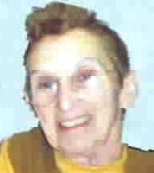
   |  | Come to our  Friends Meetings:  Saturdays at 10 a.m  in the Staff Room:  October 6  November 3  December 1  January 5

Published by the Friends of the Squirrel Hill Library

5801 Forbes Avenue Pittsburgh, PA 15217
website: www.clpgh.org/locations/squirrelhill e-mail: Friends@pittsburghusedbooks.com
editing: Joan Schwartzman production: Margie Spenser, Marion Damick, Serena Spenser mailing list: Bob Gundersen

October 2007 Among Friends Volume 1, No. 3
  Art at the  Squirrel Hill Library  Coming up are:  October: Michelle Gregio  November: Tom Keddy  oil painting  December: Ruth Drescher  photography  If you are interested in exhibiting, or know of someone who is, contact Marion Damick, 412-521-3075. | “Fall” into Some Good Books and Programs  in the Children’s Room  Our Summer Reading Club — Get a Clue @ Your Library — was a great success with over 800 super sleuths and daring detectives joining us for our mystery-themed programs! Each participant enthusiastically read or listened to stories for five hours to receive a free book and ten hours to receive a gift of a mask to decorate, kaleidoscope kit, or airplane kit—as well as coupons and a few other fun prizes!  Through the continued support of the Friends of the Squirrel Hill Library, our community service aspect of Summer Reading Club was to give five cents to the Greater Pittsburgh Food Bank for every hour spent reading or listening to books. We are thrilled that the result of this challenge is a $200 donation to the Greater Pittsburgh Food Bank. Every dollar donated to the Greater Pittsburgh Food Bank generates five dollars worth of food for our communities. Congratulations to every child, teen, and adult who helped us raise this money!  You may have seen our staff and Friends volunteers proudly wearing orange or pink “Get a Clue @ Your Library!” t-shirts. These t-shirts were provided by the Friends of the Squirrel Hill Library to help promote our programs and summer reading. Some of our Summer Reading Club highlights included: a magic show with Doc Dixon, a family sing-along with Margaret Hooten, and a magical night of fun celebrating the seventh Harry Potter book, Harry Potter and the Deathly Hallows at Carnegie Library of Pittsburgh-Main in Oakland.  We also had a lot of fun this summer trying to solve the mystery of the missing cookies. We knew the cookies were somewhere in Pittsburgh; however, we had to solve nine weekly riddles to finally discover that Dippy the Dinosaur (the large Diplodocus sculpture outside of the Carnegie Natural History Museum) had eaten all the cookies! Luckily, the Friends of the Squirrel Hill Library helped us buy some delicious cookies from Simple Treat Bakery for our Summer Reading Club finale party on August 15th.  School has started again and the smell of newly sharpened pencils is in the air. Already, children and their grownups are coming into the library for homework help and to relax after a long day at school. We will begin our programming year in October and look forward to sharing stories, songs, games, and crafts through our regular programs and outreach to daycares, preschools, and schools. We are especially excited about a new program—KinderPrep—which was created by Carnegie Library of Pittsburgh and will be presented at several different locations. KinderPrep is a literacy-based program designed to reinforce skills for children entering Kindergarten in Fall 2008. This program will be held on the third Tuesday evening of every month from October through May. Stop by our Children’s Room for more information and to register!
  To learn to read is to light a fire;  every syllable that is spelled out is a spark.  Victor Hugo, 1802- 1885  ORIGINALLY PRINTED IN  CAC MOOSE  by Megan  Gallagher  Children's  Librarian | 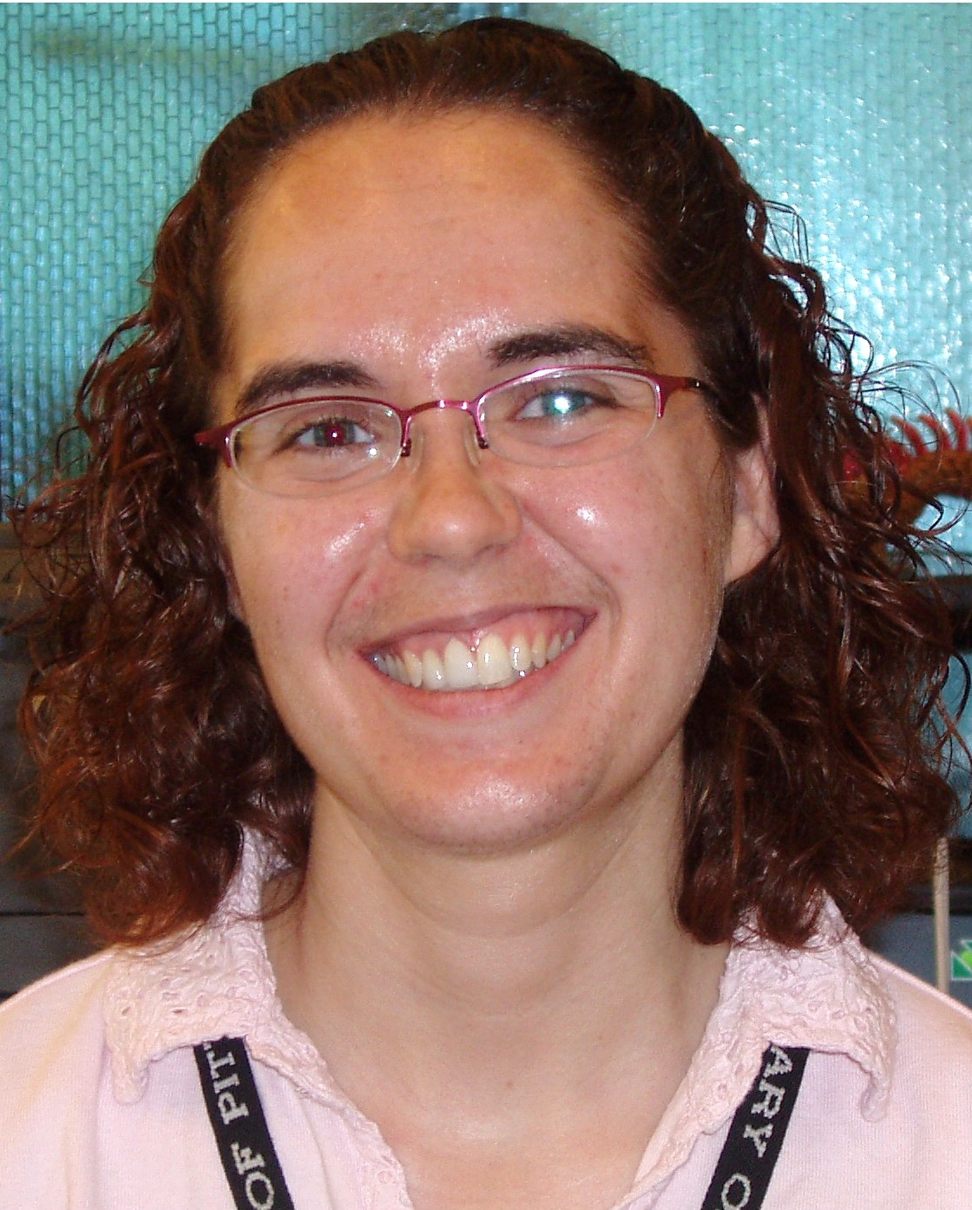
WEEKLY EVENTS

Join us at any of our
regular programs
starting in October, including:

Family Storytime:
Mondays at 6:00PM and Saturdays at 11:00AM

Toddler Storytime:
Tuesdays at 10:30AM
and 11:30AM

School-age Fun:
Wednesdays at 4:30PM

BabyLapsit:
Thursdays at 10:30AM
and 11:30AM

Check out our website for more fun programs: http://www.carnegielibrary.org/ kids/happening/

2

October 2007 Among Friends Volume 1, No. 3
 | Teen Summer Reading was spectacular this year! Squirrel Hill library had 145 teens taking part in the 10 week program, reading a total of 985 books. These numbers are the highest for any Carnegie branch library. Throughout the program five $10 gift cards for Barnes & Noble, five $10 gift cards for Target, and one MP3 player were randomly given out as
  TEEN NEWS  by Kim Parker, Teen Librarian | 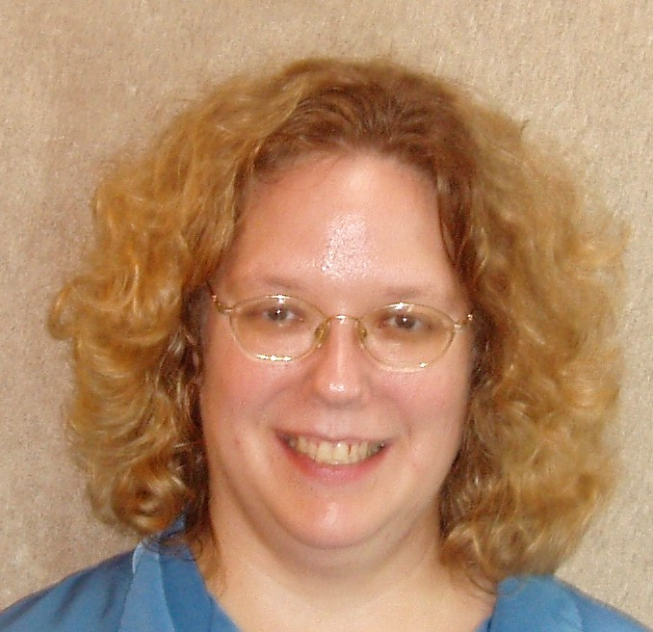
prizes to teens entering book reviews into the Library’s web site.

We are excited to be starting the Carnegie Library’s gaming program this fall. Beginning in October the branch libraries will share two gaming consoles (a Nintendo Wii and a Playstation PS2) along with some of the more popular age appropriate games. (ex: Guitar Hero II) Once a month the consoles and games will travel from branch to branch, giving teens the opportunity to meet new people and to develop some social and communication skills. Schedules will be printed out and posted on the web site.

Also in October, Squirrel Hill Library will host the first of Carnegie Library’s Behind Books: Authors Talk to Teens programs. Ned Vizzini, author of Be More Chill; It’s Kind of a Funny Story; and Teen Angst? Naaah, will be speaking at the library on Wednesday, October 24th from 6:00pm to 7:00pm. Space is limited. If you are interested, please register by calling Karen Brooks-Reese at 412-578-2599.

Fiction, Film, and Fun  The Film, Fiction, and Fun program series is an ongoing exploration into the relationship between classic novels and the films they inspired.  On Thursday, October 25th at 1:00 PM, the classic film, The Picture of Dorian Gray will be presented. Participants are  The next book and film to be discussed will be John Steinbeck’s The Grapes of Wrath on December 20th. |  | The Squirrel Hill  Adult Book Discussion Group  meets on Thursdays from  1:00 PM to 2:00 PM.  All are Welcome.  October 25th  The Good Good Pig  by Sy Montgomery  November 29th  Uncle Tungsten:  Memories of a Chemical Boyhood  by Oliver Sacks  December 27th  Beautiful Jim Key: the Lost History  Of A Horse And A Man  Who Changed The World  by Mim Eichler Rivas
  encouraged to read the novel by Oscar Wilde, then join us for a screening of the film and a discussion to follow, led by CCAC's Jeanne Bergad. | 

The only thing to do with good advice is to pass it on.
It is never of any use to oneself.
Oscar Wilde- 1854-1900
ORIGINALLY PRINTED IN CAC MOOSE

3

October 2007 Among Friends Volume 1, No. 3

September Mini-Sale Earns Record Profits;  Holiday Shopping Sale Will Brighten Up November  by Pat Bender, mini-sale chairperson  The first mini-sale of the new season is behind us and we are gratified, once again, by our customers' positive responses -- especially the pleasure they get from their "finds." The low prices add to the happy atmosphere. This sale [of Religion/Philosophy and Judaica] resulted in $425 being added to our treasury.  During the October book sale, your author the "mini-saler" will have a preview sale of handcrafted FOL book jewelry and other FOL jeweled | 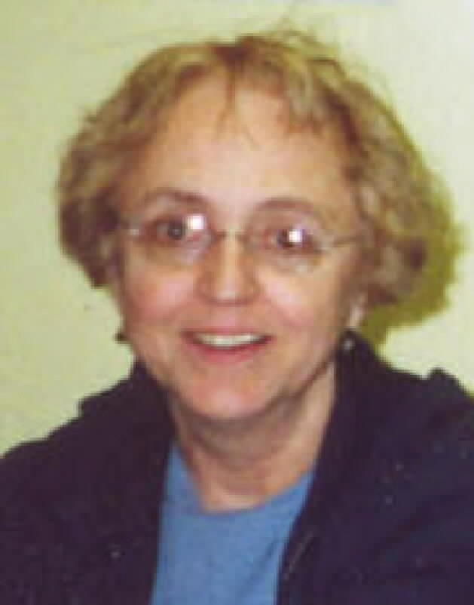
necessities,a larger selection of which will be available at the November sale.

The "like new" book sale will be held November 16-18 during library hours. All of the books are without blemish and suitable for holiday gifts. Thanks to a recent donation, there is a huge selection of outstanding cookbooks.

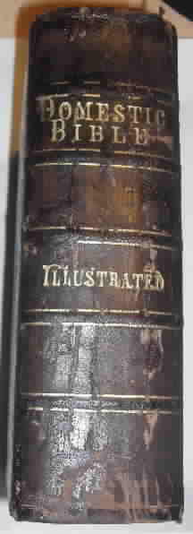  In April, we received a copy of The Domestic Bible: Old and New Testaments as a donation. Printed in 1868, this piece of the past contains commentaries and author's notes on every page, along with many illustrations and the traditional section in the middle for recording vital information about the family.  The front cover has the names of the Morgan family inscribed in gold, and the Marriages page records that John and Rebecca married in 1866. The Births page reveals that they had two daughters. On the following page, we learn that John died only 8 years after the Morgans were married, and Rebecca stopped writing. It's time for a new family to start recording a happier history.  Chances to win this lovely book will be sold at the Customer Service Desk until the Fall Used Book Sale. Tickets are just 50¢ or 3/$1. We will hold the drawing to see who wins this Bible on Sunday October 28 at 4:00 p.m. The winner need not be present.
  Family Bible
  Tells Sad Story
  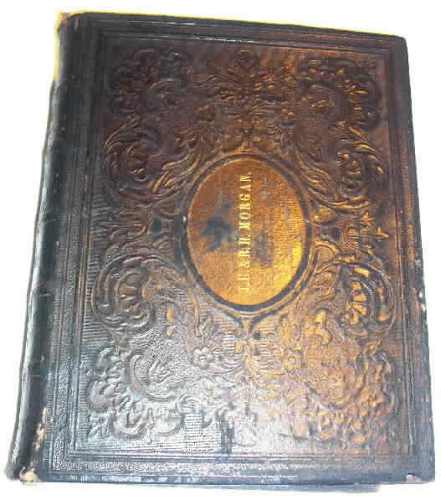
  BOOKS, BOOKS, BOOKS, BOOKS, BOOKS, BOOKS………  Our July Fiction Sale did well this year; we took in more than $1800. After a rainy start on the first day of the Squirrel Hill Sidewalk Sale, we had lots of customers and recycled a lot of fiction, foreign language books, and tapes and disks. It was a nice adjunct to the library's Adult Summer Reading Program. | 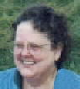 Margie Spenser  Book Sale Committee
 | Coming up is our longest-running sale, the Fall Used Book Sale, to be held on the weekend before Halloween. Each year at this time, we put out all the books we have in stock, and give everything we don't sell to a non-profit organization.  This year, our overflow will go to the library in the Allegheny County Jail. We are happy to announce that they are also looking for TEXTBOOKS. On their behalf, we will resume accepting donations of textbooks for all levels of students. No books about chemistry, electronics, computers, or repairing locks, however! And we still cannot use: encyclopedias; very old, dirty, or damaged books; magazines; or books with no front cover.  An unfortunate thing about the world is that | Two added features of the October sale are worth repeating here: the drawing of the winning ticket for the Domestic Bible (see the article to the left) and the first public offering of Pat Bender's hand-crafted Friends of the Library jewelry. I can't say the first sale of these marvelous items, because I already bought the sample she brought to our meeting!  Pat has also been busy for months, sorting books for her last mini-sale of 2007, the Holiday Shopping sale. It has been expanded to begin a day earlier this year because of the large number of gorgeous like-new volumes we'll be offering. Mark your calendars now for a trip to the library on November 16-18.
the good habits are much easier to give up than the bad ones.
-- W. Somerset Maugham
1874-1964
ORIGINALLY PRINTED IN CAC MOOSE
4

44

October 2007 Among Friends Volume 1, No. 3
 | IRA Rollovers:  get answers to frequently asked questions.  Wednesday, October 17, 2007; 10:15 AM - 11:00 AM  Presented by David Gettemy, UBS.  Financing your business:  learn about the money essentials to realize your dream.  Wednesday, October 24, 2007; 10:15 AM - 11:00 AM  Presented by Matthew Napolitan, PNC Financial Services Group.  How do you evaluate a stock?  Learn the key fundamentals and hear about favorites  of a Pittsburgh stock broker.  Wednesday, November 14, 2007; 10:15 AM - 11:00 AM  Presented by Steven Sheffler, UBS.  Marketing on a shoestring:  discover low cost, high impact strategies for your business or organization.  Wednesday, November 28, 2007; 10:15 AM - 11:00 AM  Presented by Catherine Brennan, President of A Cappella Marketing.  Is your business a potential exporter? Export to Europe:  learn how to tap into a lucrative market overseas.
  NAMM BUSINESS CENTER PROGRAMS  October - December 2007  by Dorothy Kabakeris,  Namm Business Center Librarian | 
NAMM Newsletter
Published Monthly

The most recent issue of the NAMM newsletter featured this Database of the Month:

The Business Plans and Profiles Index, developed by the Downtown & Business Library of the Carnegie Library of Pittsburgh, is a one-of-a-kind superb and comprehensive index to over a thousand different business plans in books and on the web. See it at:
www.carnegielibrary.org/subject/
business/bplansindex.html

For the rest of the info on this DB, and for lots of other NAMM
news, sign up to receive the newsletter at: squirrelhill@ carnegielibrary.org.
One's favorite book is  as elusive as  one's favorite pudding.  -- E. M. Forster  1879-1970 | Wednesday, December 12, 2007; 10:15 - 11:00 AM  Presented by Daniel Assmus, Duquesne University,  Center for International Regulatory Assistance.  Hone your job seeking skills  to land a great job.  Wednesday, December 19, 2007; 10:15 AM - 11:00 AM  Presented by John Gilmore, The Career Development Center.
Special book signing:
The Last Chicken in America by Ellen Litman, W.W. Norton, 2007.
Meet the author of this dazzling debut novel – twelve linked, wryly humorous stories about an
unforgettable cast of Russian-Jewish immigrants trying to assimilate in a new world, in Squirrel Hill!
The author immigrated to Squirrel Hill from Moscow in 1992 and currently lives in
Somerville, Massachusetts. Ms. Litman will have a book-signing afterwards.
Save the date! Thursday, October 18, 2007; 1:00 PM - 2:30 PM

5

October 2007 Among Friends Volume 1, No. 3

I have not heard from any of you about things you would like to see published in the FOL Newsletter. If you have an original poem, essay, photo, drawing, or shaggy-dog story, send it to Friends@pittsburgh usedbooks.com and we'll see if it fits in the Friends' Corner. It would be great if some of the unknown writers in our groups became known.You don't have to be a member of the Friends. Or if you see an interesting article elsewhere, send us a clipping. We also welcome letters to the Editor. Please include a phone number or e-mail address with anything you send so we can confirm your permission to publish it.  By passing out copies of the FOL Newsletter I have increased our membership by 10. It is a good way to get local patrons interested and involved. Additional copies are available at the library. Show the public what we accomplish!  Have a happy holiday season.  Some books are to be tasted,  others to be swallowed, and  some few to be chewed and digested.  —Francis Bacon 1561-1626 | Friends' Corner  POETS  Are poets really mad? I suppose poets have always been a little  mad,  But in a different way. It used to be that they would sing,  And I could follow. And now I can’t.  They talk of snow, and suddenly they’re mentioning rats or  mothers  Or monsters under their beds. I am completely left behind.  Perhaps it’s the fault of Sesame Street, with the  Count always falling down the stairs,  And the strange miscegenation of frogs and  pigs. It surely wasn’t Mister Rogers,  who knew which way the trolley was running, and that the  King was make-believe.  If I sing of snow, the sparkle of it, the chill  of it – at least there are no snakes  Or stealth planes or boys who wouldn’t take me to the Senior  Prom.  But today I did my laundry, and forgot to put in the soap.  Perhaps I am a poet, after all.
  From the Editor  by Joan Schwartzman | 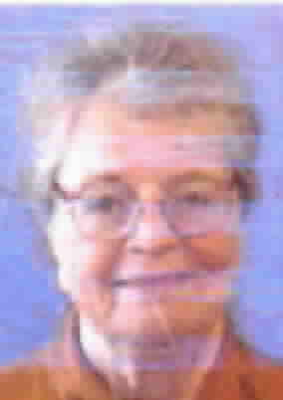
  Esther Jacobson Tucker is back with another view of poets and poetry. We are grateful for her generosity – when her work appears in the Post Gazette or the Washington Post she gets paid! | 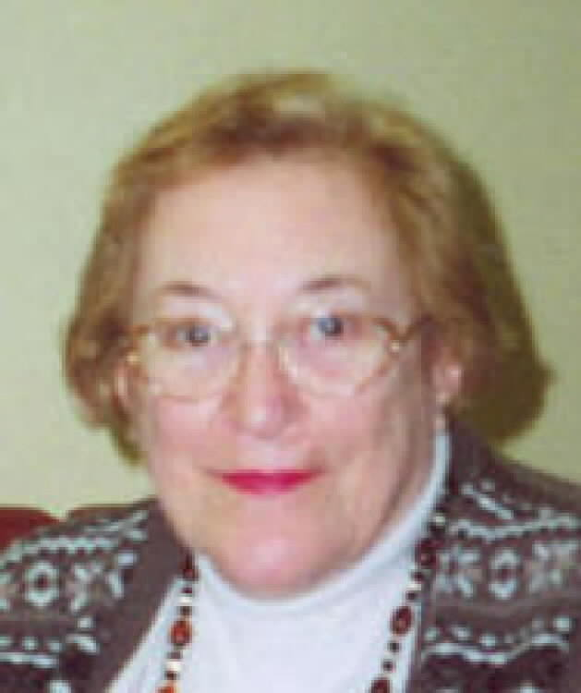

Great New Library Offering
Since September 1st the library has offered downloadable video. With your library card you can now download digital video directly from our website to your computer or a compatible portable device. Here is a small sampling of the over 700 titles that we have available:  - Broadway Theatre Archive productions such as Hamlet and The Glass Menagerie  - Imax films  - Music instruction and concerts (Cher, Chick Corea, Cream, Macy Gray,Go-Gos, James Brown, Melba Moore, The Ramones, Herbie Hancock, Roy Orbison & more)  - Classic bad/funny B-movies  - Yoga, exercise videos, and self-improvement titles | - Children's classics such as The Ugly Duckling, The Velveteen Rabbit, The Tale of Peter Rabbit, Rumpelstiltskin, Red Riding Hood, Pinocchio, The Legend of Sleepy Hollow, and Anansi.  - Films and Documentaries such as  - The World’s Fastest Indian (Anthony Hopkins)  - Fellini’s 8½  - Endless Summer (surf classic)  - Nosferatu  - Paper Clips  - Super Size Me  - Enron: The Smartest Guys in the Room  - Pittsburgh’s own Night of the Living Dead  - the films of Charlie Chaplin.  Visit the library website, www.carnegielibrary.org, or ask one of our librarians for more information.

6

October, 2007 Among Friends Volume I, No. 3

Support the Library's Regional Asset District Request

Dr. Barbara Mistick, President and Director of the Carnegie Library of Pittsburgh, appeared before the Allegheny County Regional Asset District (RAD) board on August 27 to request a $1 million funding increase for the 2008 operating year. The request calls for $17,764,000, which will allow the Library to increase library hours, preserve its historical collections, provide services to children and teens and improve technologies in each neighborhood library. | 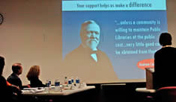
The Library's RAD budget request also includes an additional $5.4 million for capital improvements for the Library’s 19 locations. The proposed capital improvements include adding air conditioning and handicapped accessibility to several neighborhood libraries and upgrading the space used for county-wide shipping and distribution.

Dr. Mistick stressed the importance of local funding to support libraries. Libraries nationwide receive an average of 81% of their funding from local government, while CLP gets only 62% of its funding from local government.

The original intent of RAD was to provide a dedicated funding stream for library services and parks, assets which are widely enjoyed and contribute to the quality of life for people throughout the county, generally at no charge to users. The Library’s 2008 funding request relies primarily on local dollars, as founder Andrew Carnegie originally intended.

“Carnegie Library and RAD have been good partners,” stated Mistick. “We need to continue to work together to make sure that libraries are seen as a priority by our community and funded accordingly.”

“Pittsburgh is woefully behind comparable cities in the amount of dollars the library spends per capita,” Dr. Mistick continued. “Compare our $16 per resident to Cleveland’s $120 or Philadelphia’s $42 per resident. How can our region be a leader when our libraries have so little to spend on providing critical community services?”

RAD will announce its preliminary budget allocations on October 1, at which time they will be open for public comment. Citizens can express their support for Carnegie Library of Pittsburgh’s funding increase by contacting the Allegheny Regional Asset District directly. See the box below for contact information.

There are only two tragedies in life;  one is not getting  what one wants,  and the other is  getting it.  Oscar Wilde  1854-1900 | The Friends of the Squirrel Hill Library  5801 Forbes Ave. Pittsburgh, PA 15217  www.clpgh.org/locations/squirrelhill  Friends@ pittsburghusedbooks.com  Library – 412-422-9650  open M-W 10-7, Th-S 10-5, Sun 1-5  "Free to the People" | Regional Asset District  One Smithfield Street  Suite 310  Pittsburgh, PA 15222  Phone: 412-227-1900  Fax: 412-227-1905  TT Assistance  1-800-654-5984  E-mail: info@radworkshere.org
7
CHILDREN'S WEEKLY EVENTS

Family Storytime-
all ages-
Monday at 6 PM and Saturday at 11 AM

Toddler Storytime-
18 months to 3 years-
Tuesday at 10:30 AM- repeated at 11:30 AM

Baby Lap Sit-
0 to 18 months-
Thursday- 10:30 AM to 11:30 AM

Wacky Wednesday-
school age-
4 PM
Library Facts…
The first Andrew Carnegie free library was founded in the town of his birth, Dunfermline, Scotland, on July 27, 1881. His first American library was built in Carnegie, Pennsylvania in May, 1901, at a cost of $93,000
Joseph Frazier Wall, in his biography of Carnegie, asserts that Carnegie built 2,811 free libraries in all. Of these, 1,946 were located in the United States – at least one in every state except Rhode Island -- 660 in Britain and Ireland, 156 in Canada. A handful of libraries (49) were also scattered in places like New Zealand, the West Indies and even Fiji.
Carnegie offered interested towns enough cash to build the library, usually about $2 per resident. In return, the town had to agree to shell out an amount equal to 10 percent of that gift each year for upkeep, utilities and books.
(adapted from Chris Potter,
Pittsburgh City Newspaper)

CHILDREN'S WEEKLY EVENTS

Family Storytime-
all ages-
Monday at 6 PM and Saturday at 11 AM

Toddler Storytime-
18 months to 3 years-
Tuesday at 10:30 AM- repeated at 11:30 AM

Baby Lap Sit-
0 to 18 months-
Thursday- 10:30 AM to 11:30 AM

Wacky Wednesday-
school age-
4 PM
Library Facts…
The first Andrew Carnegie free library was founded in the town of his birth, Dunfermline, Scotland, on July 27, 1881. His first American library was built in Carnegie, Pennsylvania in May, 1901, at a cost of $93,000
Joseph Frazier Wall, in his biography of Carnegie, asserts that Carnegie built 2,811 free libraries in all. Of these, 1,946 were located in the United States – at least one in every state except Rhode Island -- 660 in Britain and Ireland, 156 in Canada. A handful of libraries (49) were also scattered in places like New Zealand, the West Indies and even Fiji.
Carnegie offered interested towns enough cash to build the library, usually about $2 per resident. In return, the town had to agree to shell out an amount equal to 10 percent of that gift each year for upkeep, utilities and books.
(adapted from Chris Potter,
Pittsburgh City Newspaper)

October, 2007 Among Friends Volume I, No. 3
 | Make checks payable to:  Friends of the Squirrel Hill Library  and bring to the library or mail to:  Bob Gundersen  518 Guyasuta Rd.  Pittsburgh, PA 15215  Check one box:  New Member Renewal  Check one box:  $3.00 $5.00 DONOR (free)  $10.00 $25.00 Other _____  Name:___________________________________  ^{(Last)} (First) (Initial)  Address: _________________________________  City/State: __________________Zip: __________  Phone(s): ___________________Date: _________  E-mail address: ____________________________  Please check all activities you can help with:  Periodic Book Sales Sorting Used Books  Adopt-a-Shelf Program Gardening  Library Advocacy Newsletter/ Mailings  (lobbying, writing letters)  COMMENTS_________________________  _________________________________  _________________________________  _________________________________
  Friends Officers  Marion Damick President  Joan Schwartzman Vice President  Eleanor Hershberg Treasurer  Margie Spenser Secretary  write us at friends  @pittsburghusedbooks.com | Friends Book Sales  October 26-29 – Fall Sale  November 16-18 Holiday Shopping  Mini-Sale  December – no sale  for sales elsewhere, go to www.pittsburghusedbooks.com
   | Did you know. . .  U.S. Embassies located in "new"  democracies have been providing  grants for the establishment of "American Corners" in academic and public libraries. These American Corners are collections of English language materials about America and democracy. They are provided in all formats, free to all – children and adults. In poorer countries, these American Corners provide patrons with the only available free access to the Internet.
     | BOOKISH WANT ADS
    YOUR AD COULD BE HERE
    Free to Friends. Call 412-521-4129
    or write
    friends@pittsburghusedbooks.com.
    Have a working color printer you don't want? We'll take it for the newsletter. Also still looking for empty HP ink cartridges, numbers 21, 22, 27, 28, 45, and 78.
    Call 412-521-4129.
    STILL DESPERATELY need tactful, persistent volunteer to verify facts for the list of Used Book Sales and Stores in and around Allegheny County. Much phoning and online checking.
    Margie@ pittsburghusedbooks.com.

Is your Friends Membership up to date? Please check your mailing label/membership card, below. If the date is before 10/07, you need to renew. If you bring this page to one of our Used Book Sales, you'll get a free book with your renewal. Or mail us the form above.
your donation is tax deductible as a charitable contribution
CARNEGIE LIBRARY OF PITTSBURGH  SQUIRREL HILL  5801 Forbes Avenue  Pittsburgh, PA 15217 |  | NON-PROFIT ORG.  U.S. POSTAGE  PAID  Pittsburgh, PA  PERMIT No. 307
Adult Services: 412-422-9650  Children's Services: 412-422-9841  Fax: 412-422-5811  www.carnegielibrary.org/clp/sq  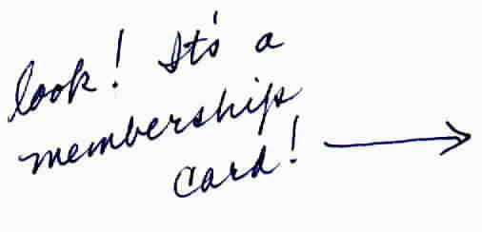
  
  EXPIRES:May 2008  Expires: | NAME  ADDRESS  CITY, STATE, ZIP
LAST NEWSLETTER IF MEMBERSHIP EXPIRES IN 2006
8

